**Building a Face-Detection App on AWS Cloud**

**1.AWS login screen with username:Y.TULASI KRISHNA DEV ROY**

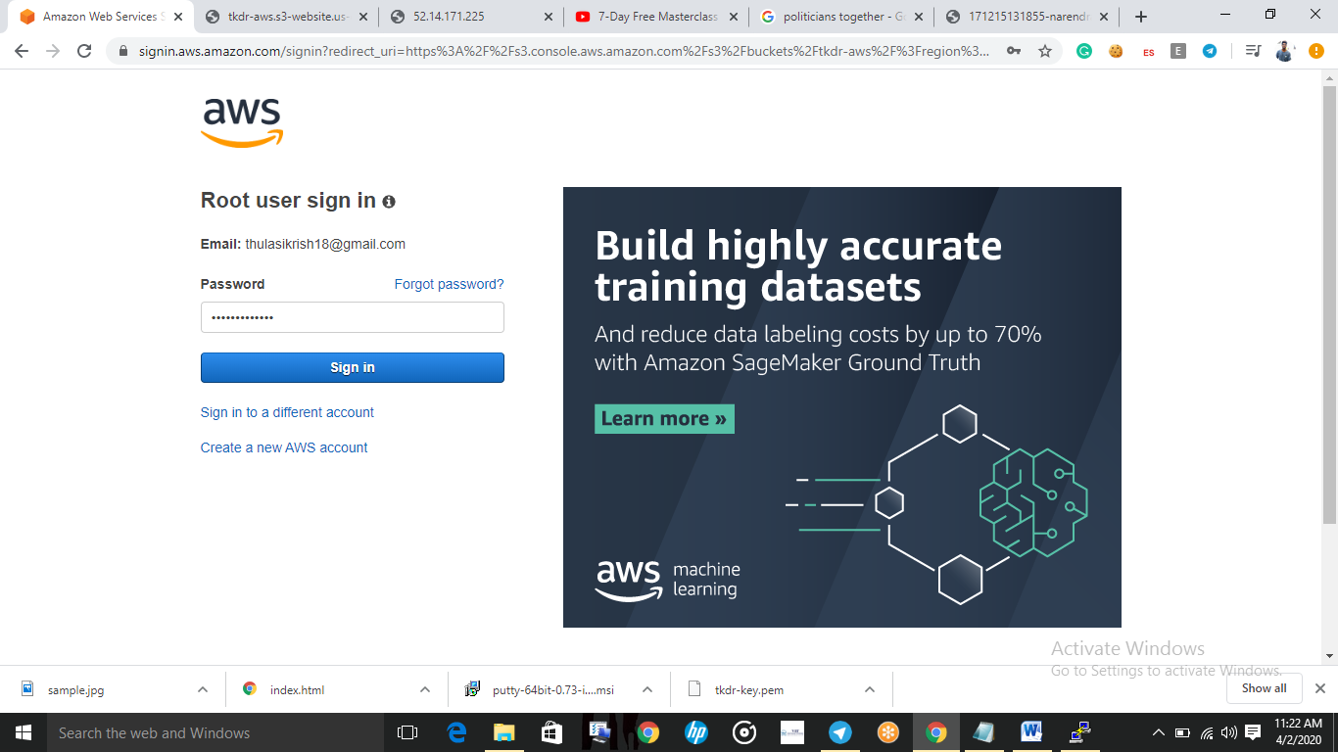

**2.EC2-dashboard :-**

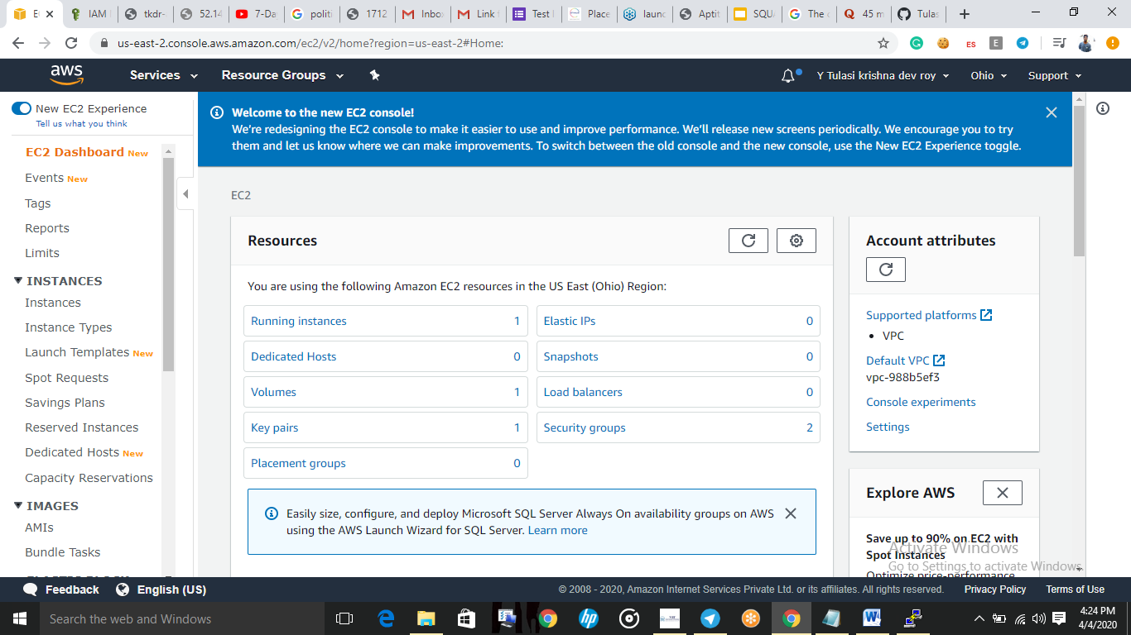

**3.S3 Dashboard :-**

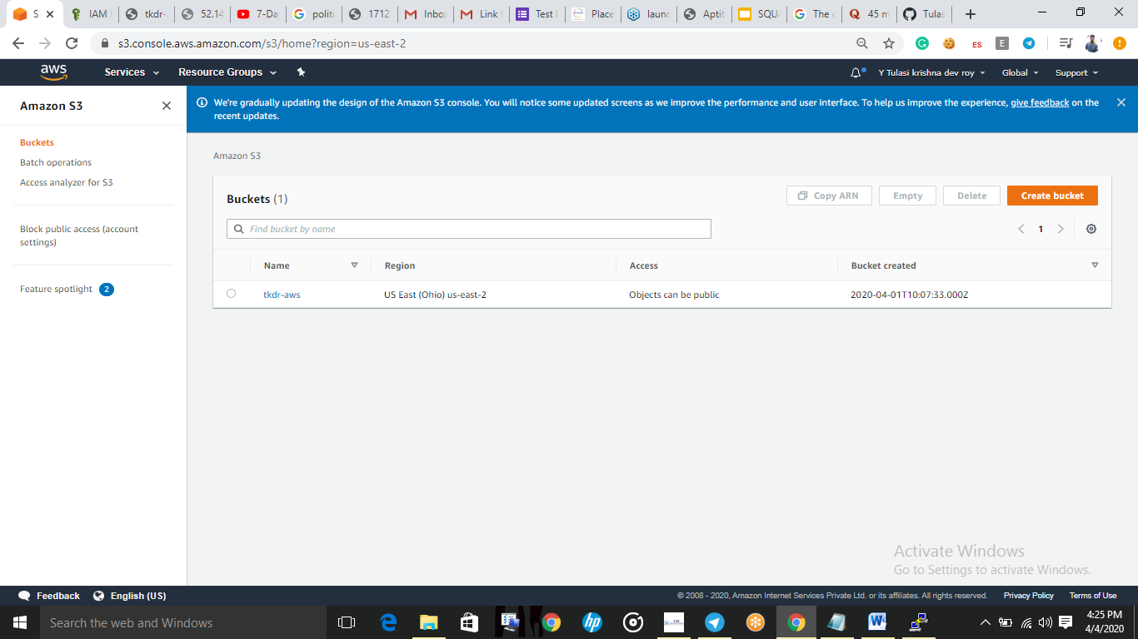

**4.Rekognition Dashboard :-**

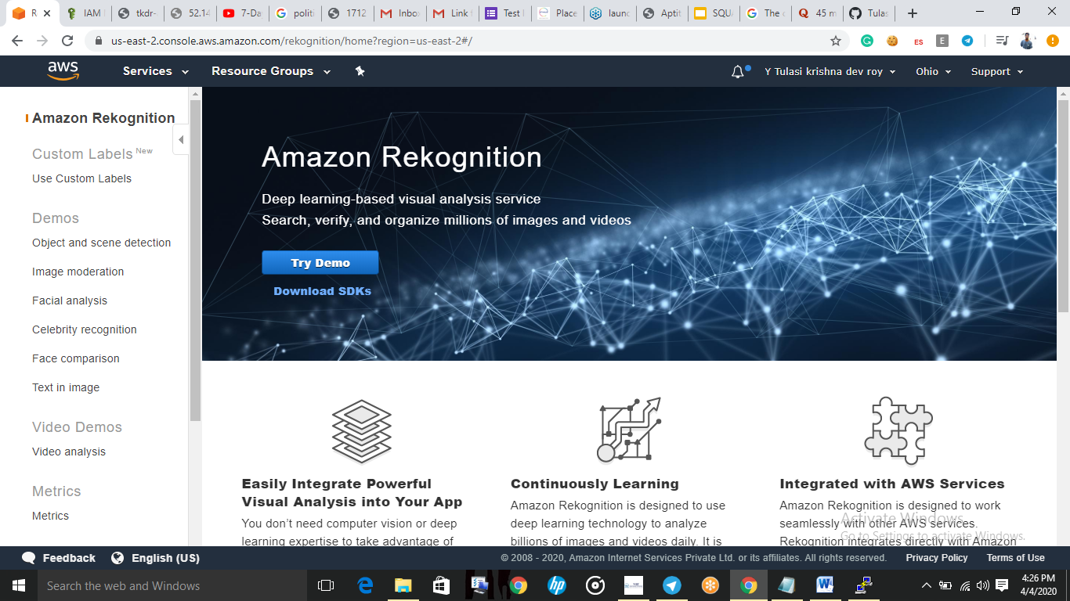

**EC2 :-**

5.Choosing an AMI :-

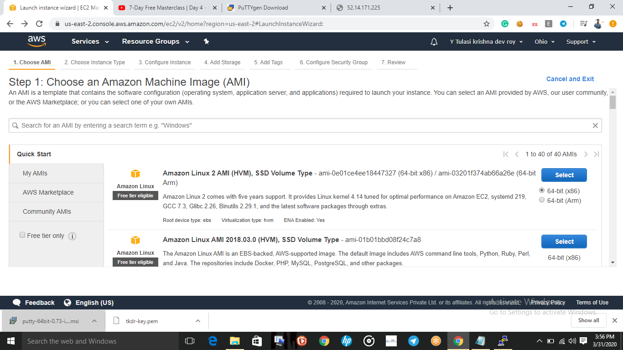

6.Choosing Instance type:-

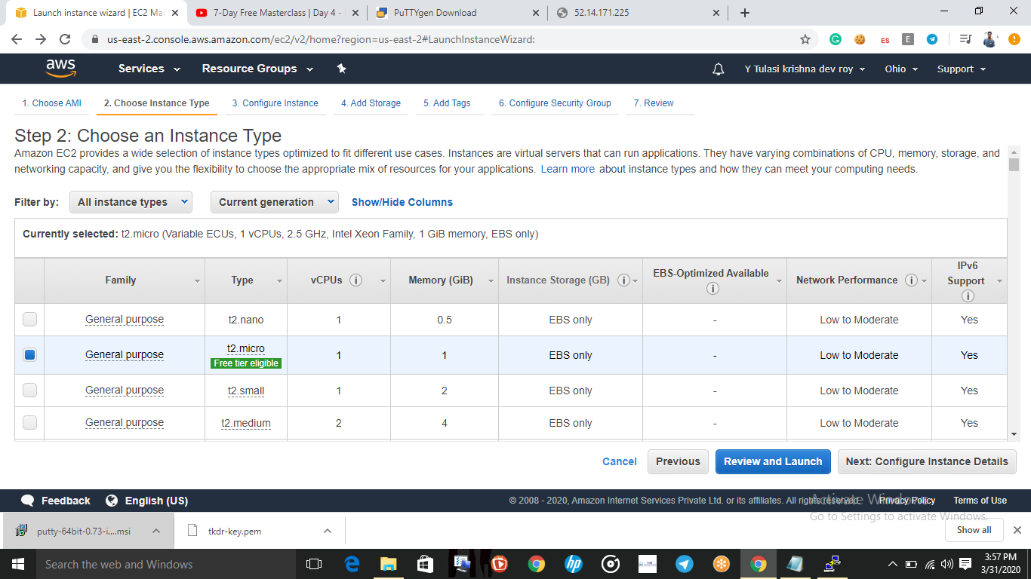

7.Adding storage :-

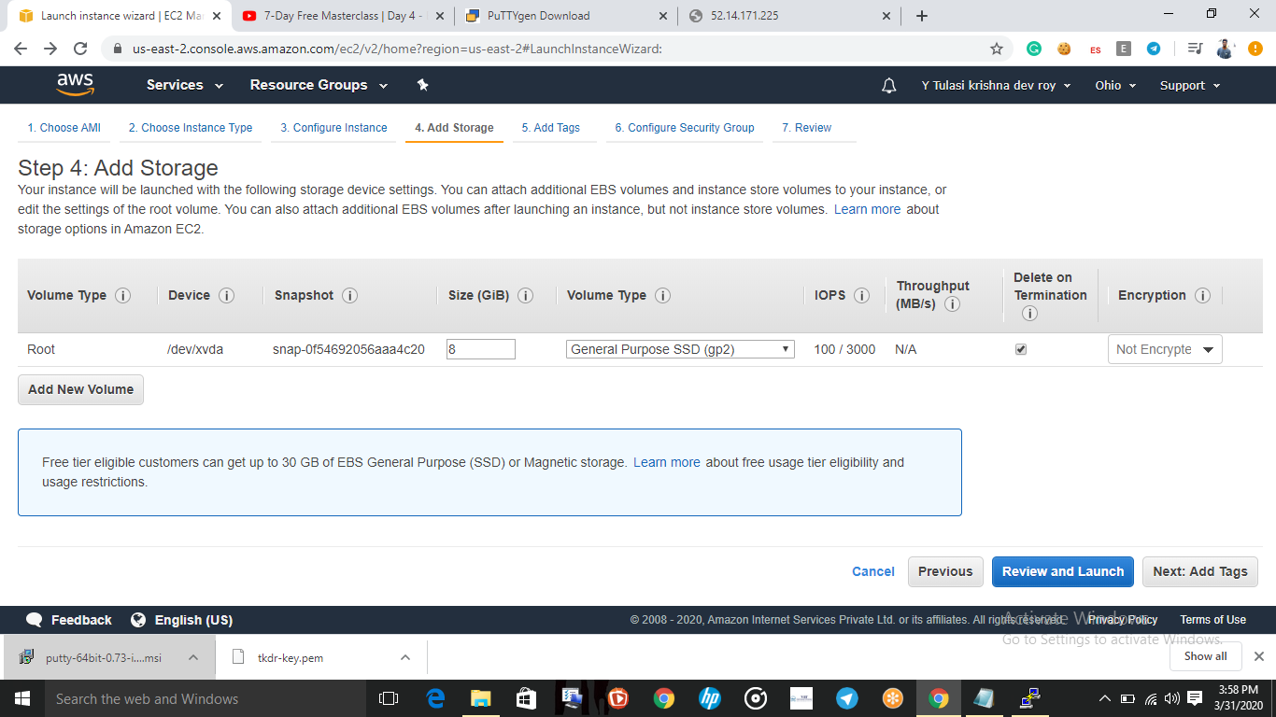

8.Configuration Security Group :

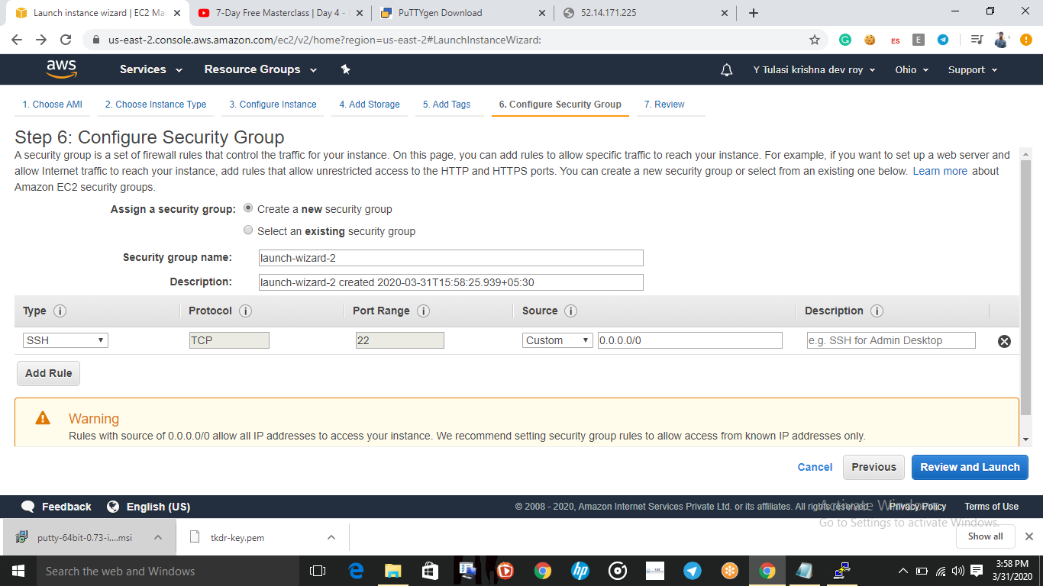

9.KeyPair download :-

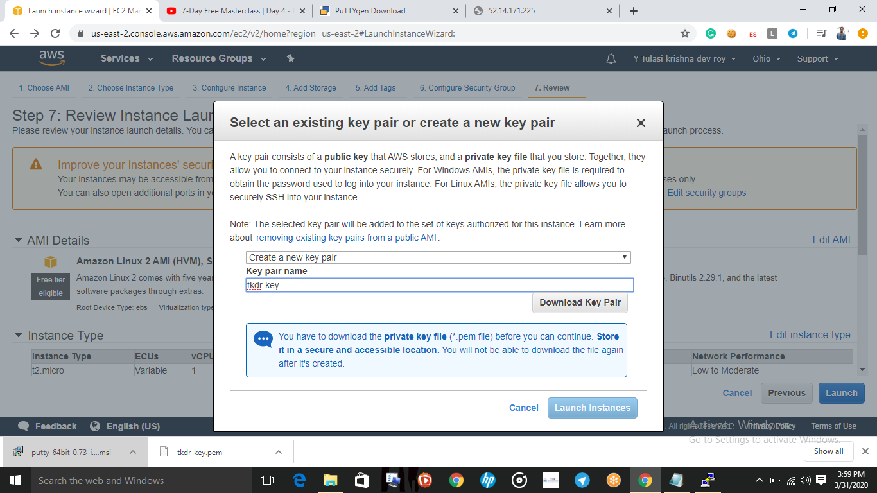

10.Puttygen conversion from pem to ppk:-

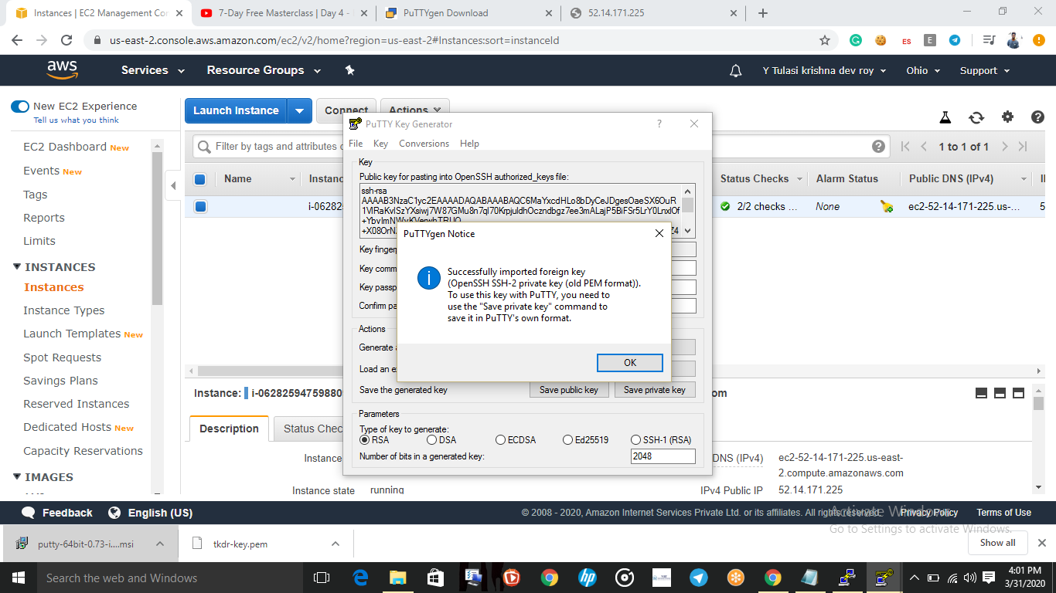

11.Logged in EC2 black-screen:

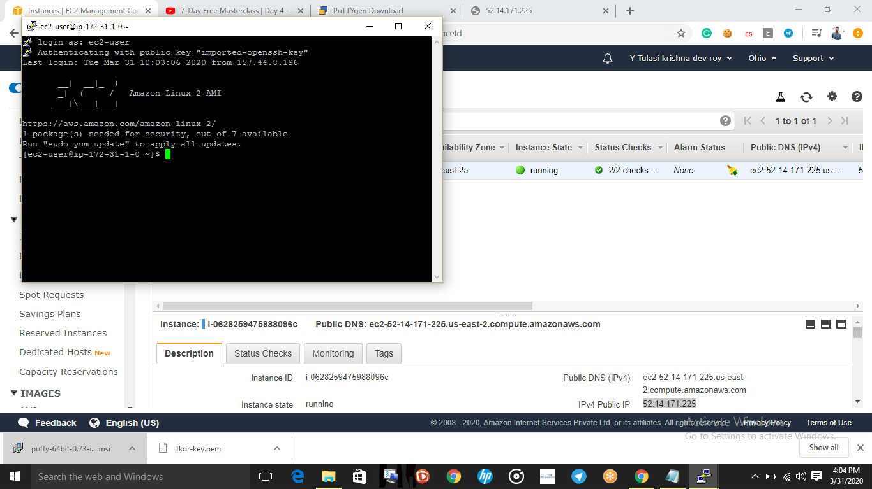

S3:

12.Creating a bucket:

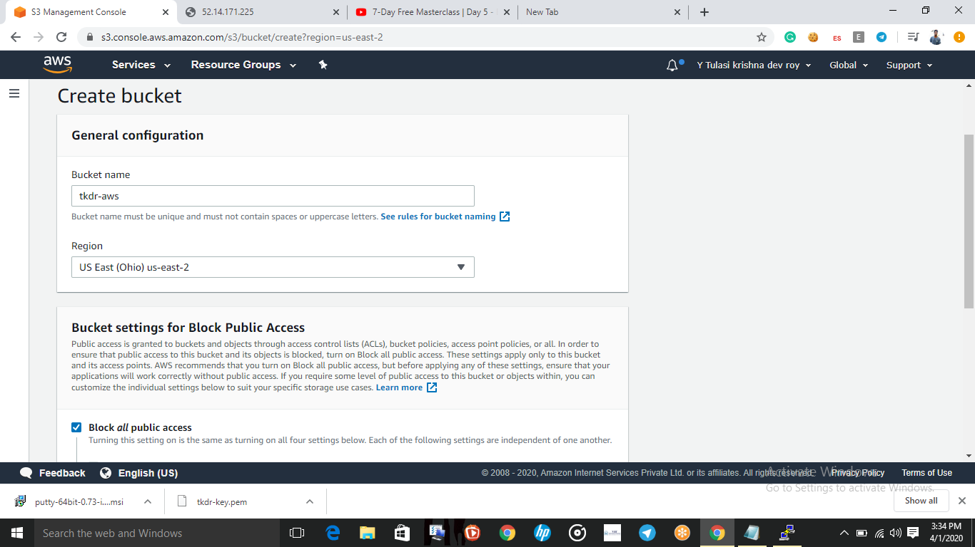

13.uploading an bject:

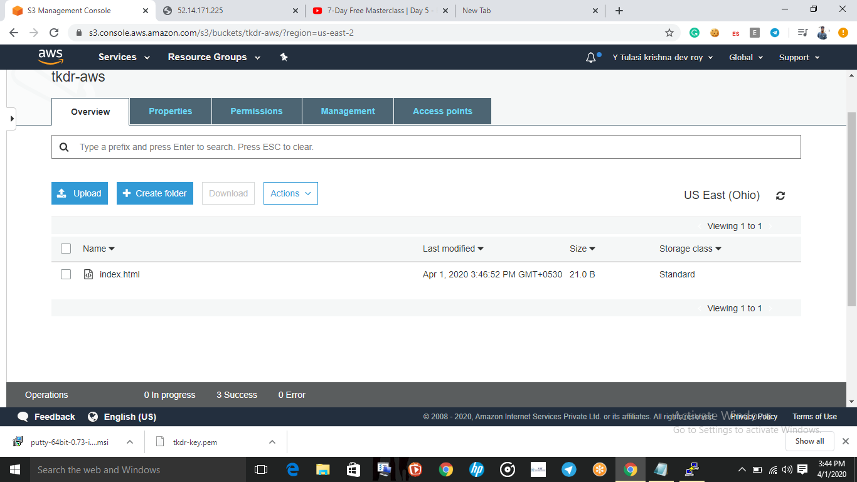

14.Enabling static website:

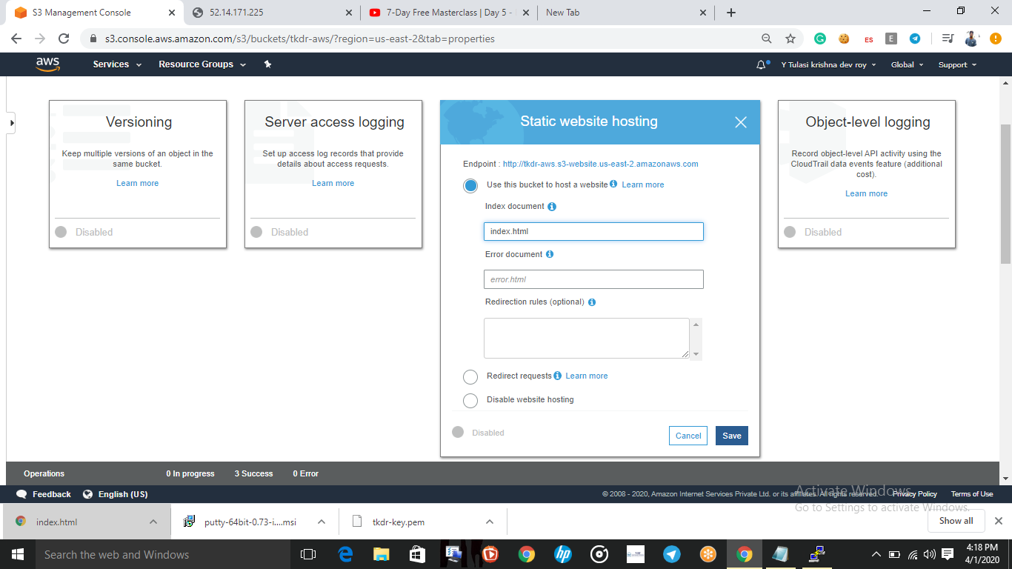

15.Making the object public:

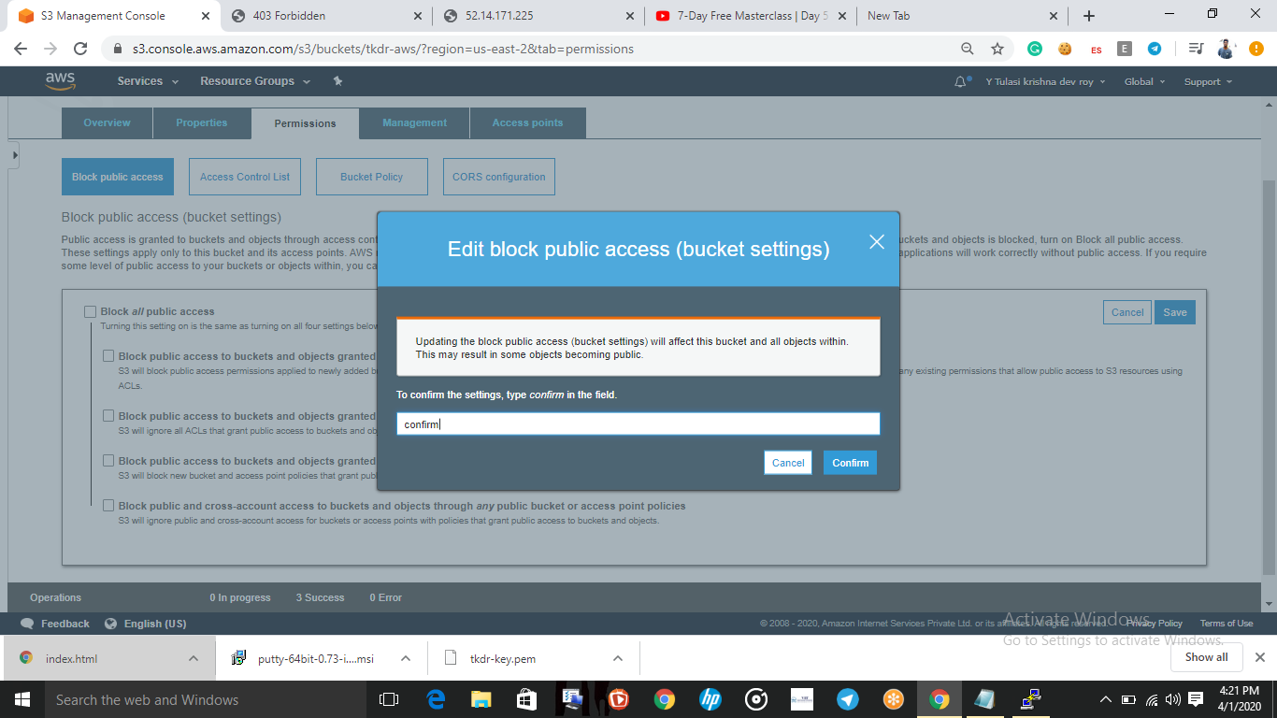

16.checking the s3 link on the browser:

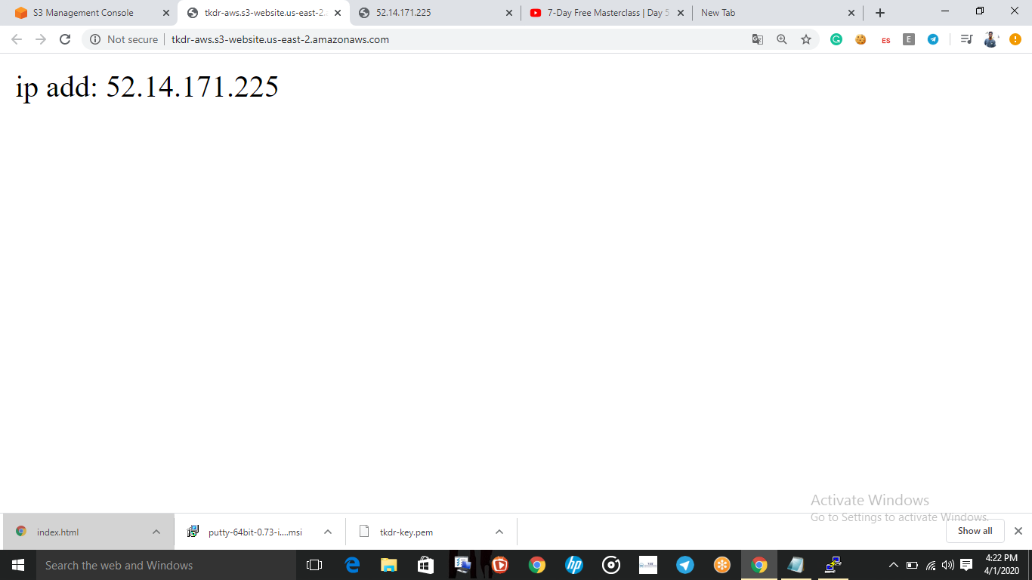

Reckognition:

17:Face Recognition:

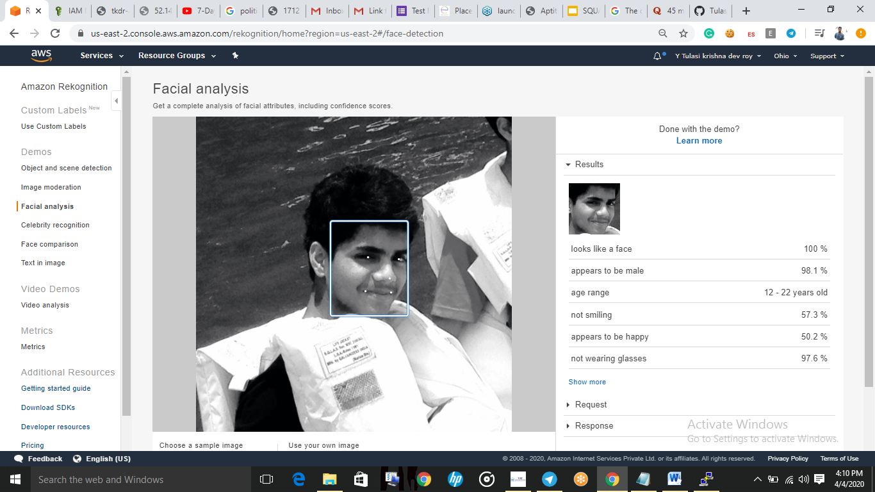

18:Face compare:

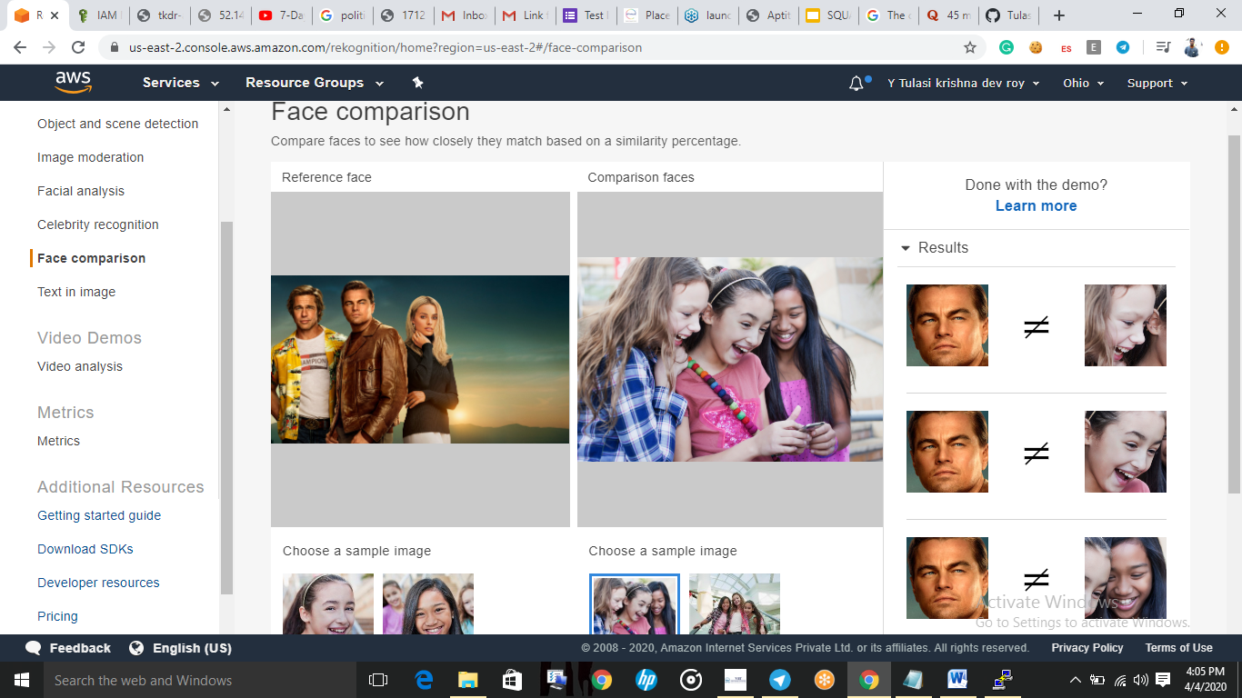

19:Celebrity Recognition:

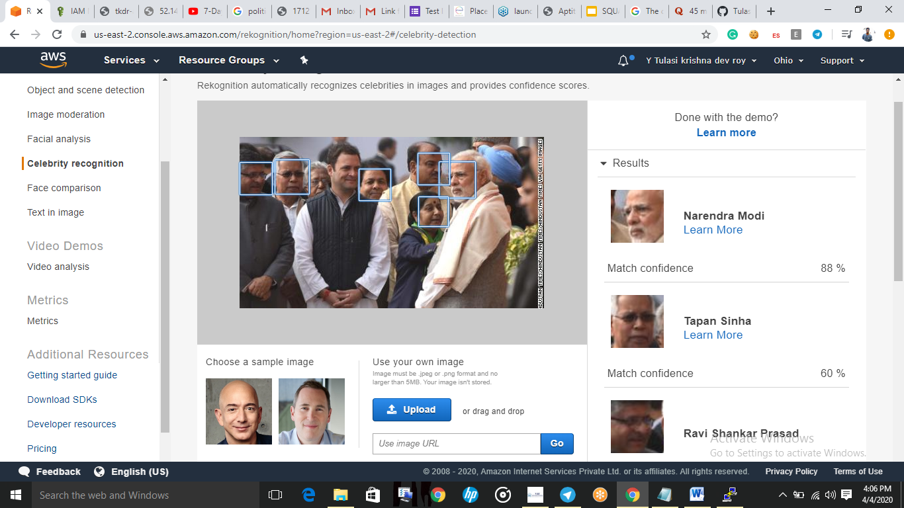

20:Text in image:

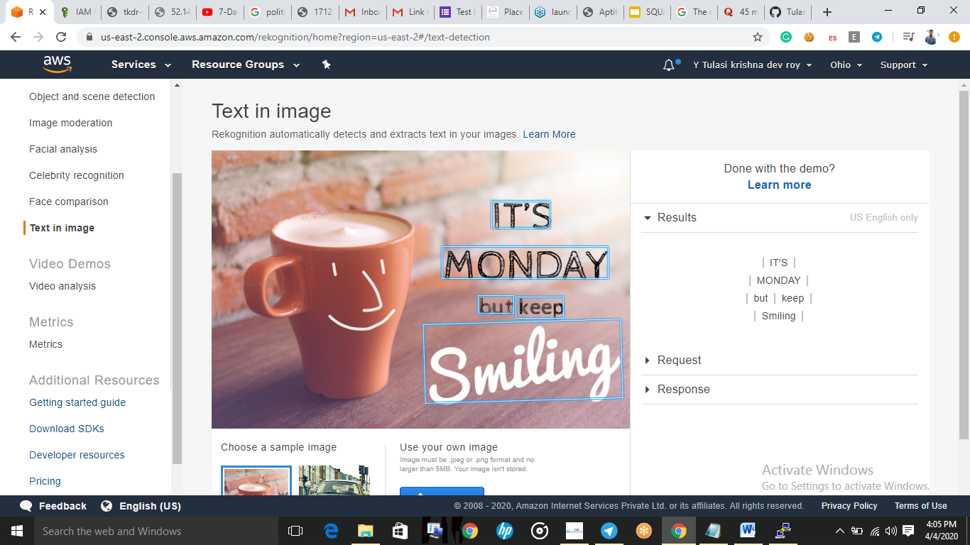

EC2&S3:

21.Installing AWS-sdk:

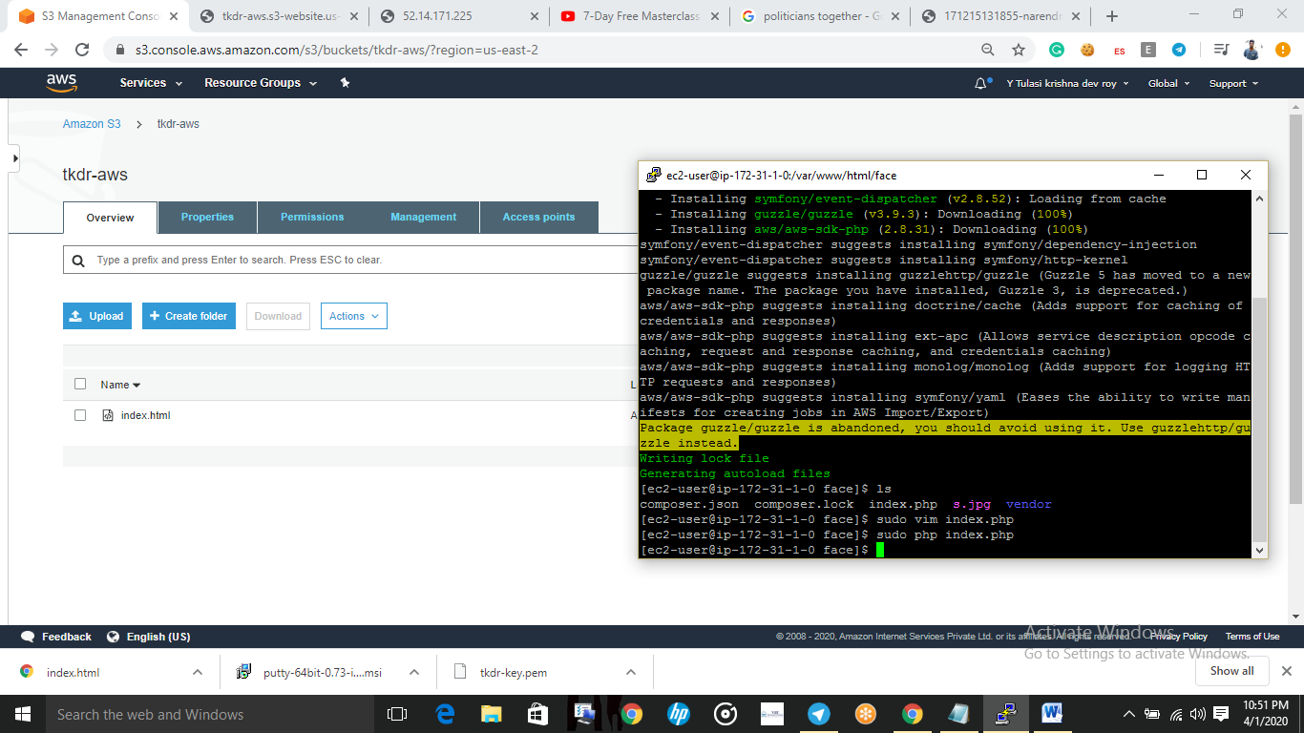

22.Installing php:

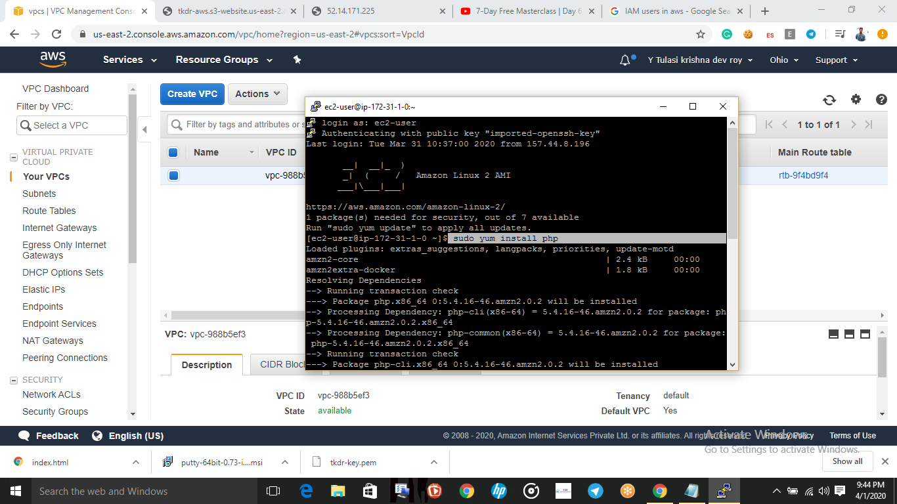

23.index.php file code:

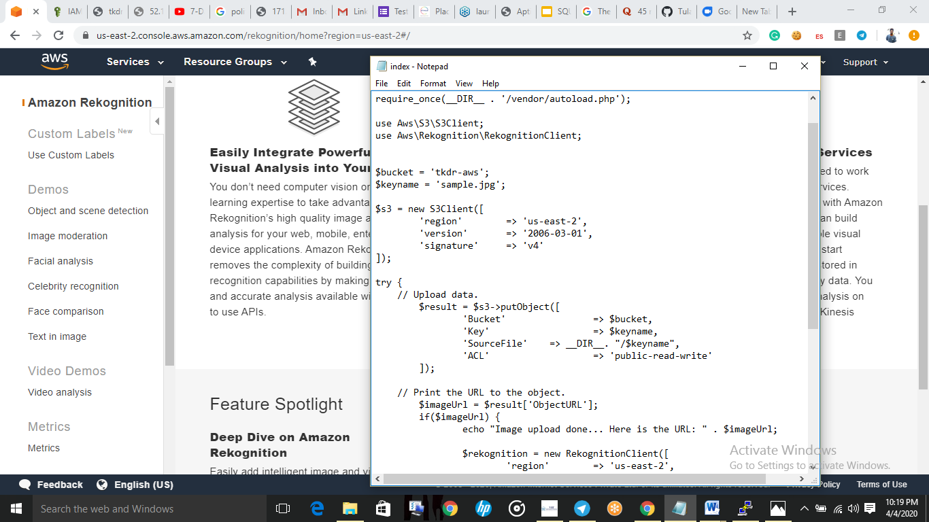

24.upload success:

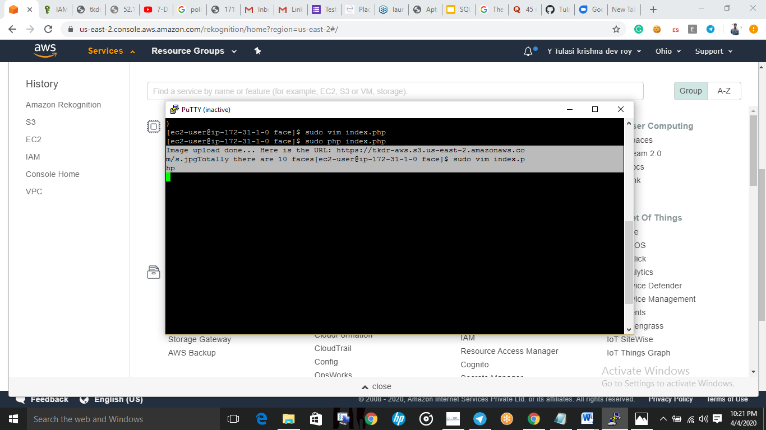

25:Face detect success screenshot:

